
HDOC day 29
Aim
To write a menu-driven C program to perform array operations such as counting elements, linear
search, merging two arrays, and exit.
Algorithm
Start.
Read the size and elements of the array.
Display the menu:
Count even, odd, positive, negative and zero elements.
Search an element using linear search.
Merge two arrays.
Exit.
Read the user's choice.
Use switch to perform the selected operation.
Display the result.
Stop.
C code
#include<stdio.h>
int main(){
int a[20],b[20],n,m,ch,x,i,e=0,o=0,p=0,ng=0,z=0;
scanf("%d",&n);
for(i=0;i<n;i++) scanf("%d",&a[i]);
printf("1.Count 2.Search 3.Merge 4.Exit\n");
scanf("%d",&ch);
switch(ch){
case 1:
for(i=0;i<n;i++){
if(a[i]%2==0)e++; else o++;
if(a[i]>0)p++; else if(a[i]<0)ng++; else z++;
}
printf("E=%d O=%d P=%d N=%d Z=%d",e,o,p,ng,z);
break;
case 2:
scanf("%d",&x);
for(i=0;i<n&&a[i]!=x;i++);
printf(i<n?"Found":"Not Found");
break;
case 3:
scanf("%d",&m);
for(i=0;i<m;i++) scanf("%d",&b[i]);

for(i=0;i<n;i++) printf("%d ",a[i]);
for(i=0;i<m;i++) printf("%d ",b[i]);
break;
case 4: break;
}
return 0;
}

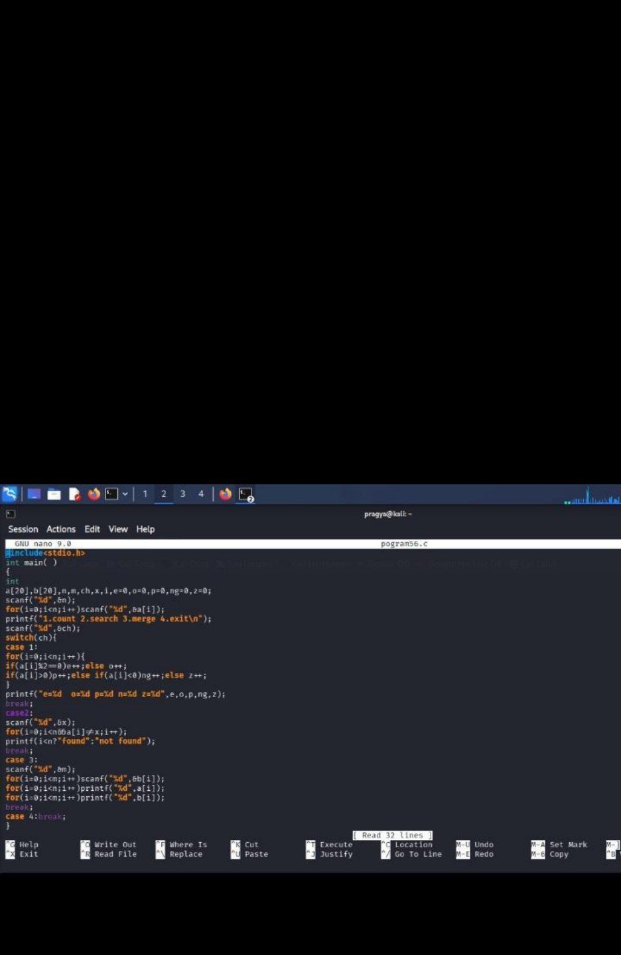

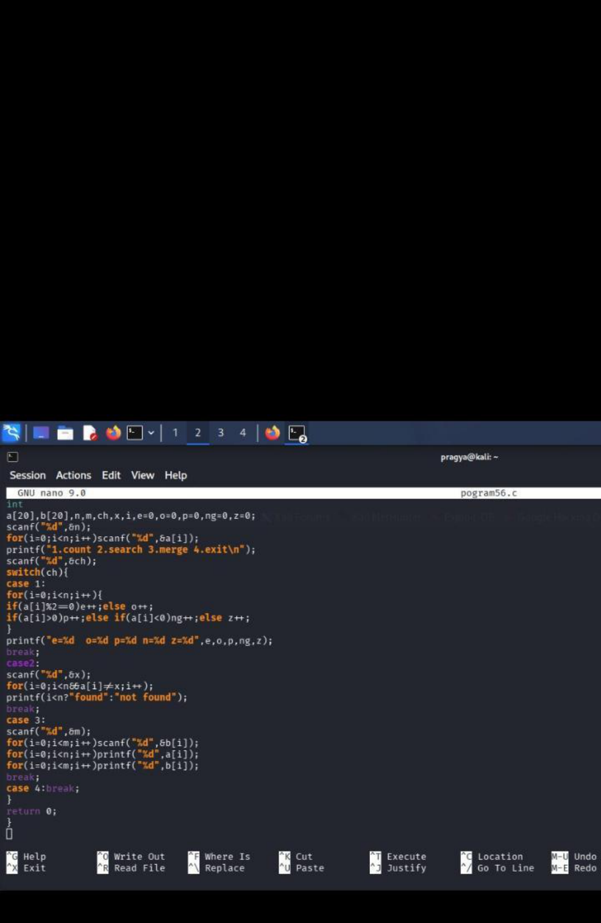

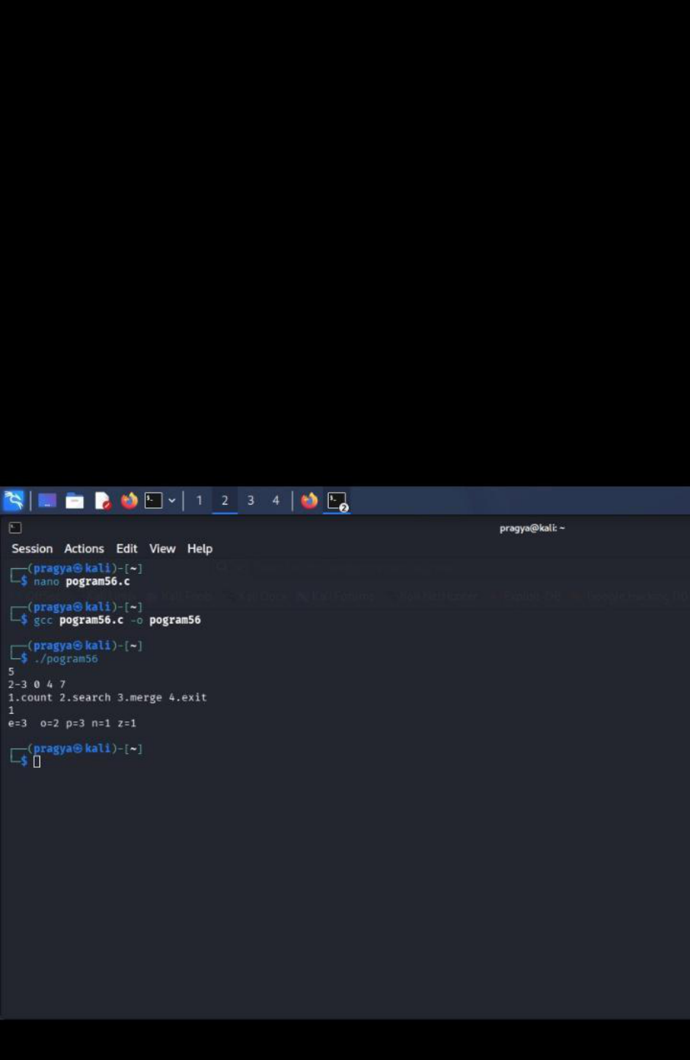

Result
The menu-driven C program was successfully executed to count array elements, search an
element using linear search, and merge two arrays.
Thank you
Pragya pandey
Sap id 590034352
Batch 15

